

PRACOWNIA 44STO SP. Z OO

based in Gliwice

st. Ziemowita 17/4, 44 100 Gliwice

NIP: 631-266-70-42



MODEL SOLUTIONS FOR DEVELOPMENT OF BUS STOPS IN KATOWICE
Design concepts using nature-based solutions (NBS)
as part of the UPSURGE project

The design team of Pracownia 44STO:
MSc. Eng. Marta Gocek, landscape architect
MSc. Eng. Ewa Twardoch, landscape architect
MSc. Eng. arch. Katarzyna Herman
Dr. Eng. arch. Agata Twardoch

Purchaser:
City of Katowice
Municipal Greenery Authority in Katowice

GENERAL ASSUMPTIONS :
- Increasing micro-retention and reducing surface runoff by removing concrete from the surface as much as possible, while maintaining their functionality, and planting plants that inhibit or delay the outflow of rainwater
- Reducing the urban heat island by planting trees, building trellises planted with vines, removing concrete from the surface, planting sodding plants
- Increasing biodiversity by planting diverse plants that are resistant and do not require care, but are attractive to fauna, melliferous plants, etc.
- Improving air quality by introducing plants that absorb dust
- Improving the comfort of space users by:
- introducing shields from the sun, wind and rain,
- setting small architecture adapted to various needs
- users to increase aesthetic values

Ochojec Hospital stop

ain conceptual assumptions
- Designing two bus shelters with roofs covered with greenery
- Designing diverse street furniture: benches, squats, litter bins
- Design of ramps and renovation of stairs
- Planting the escarpment and creating a sensory rebate at the top of the escarpment
- Planting several trees

Expected benefits
- The introduction of diverse street furniture and ramps will increase the comfort of users with special needs
- Planting the escarpment with diversified vegetation will increase the visual attractiveness of the area and biodiversity
- Planting a tree over the years will increase the shaded area, which will reduce the heat island effect

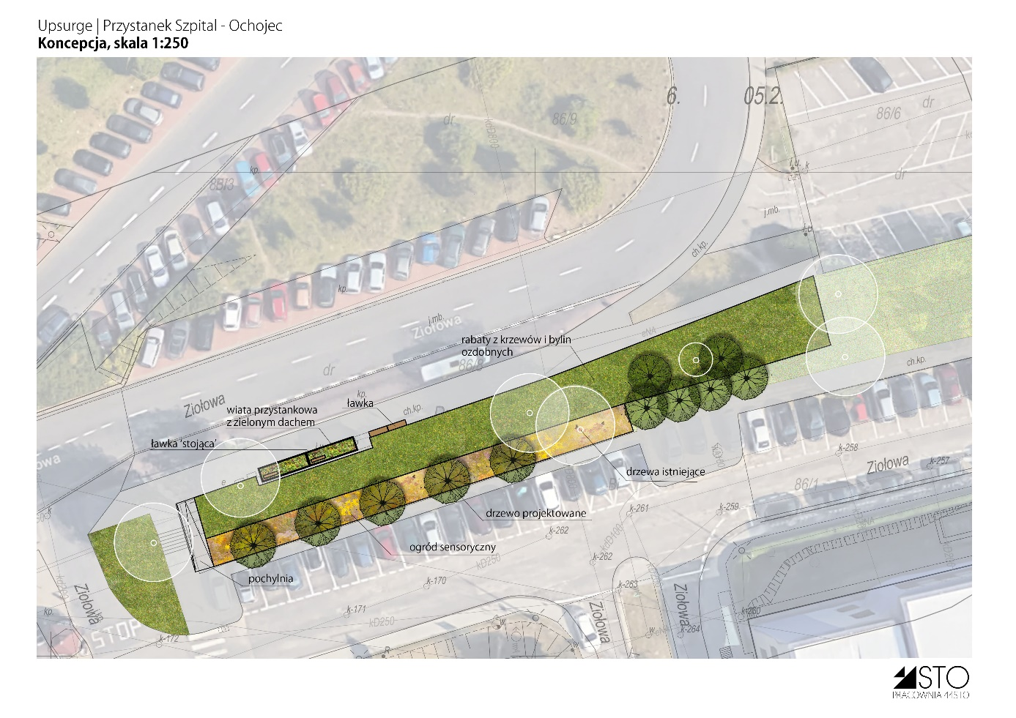
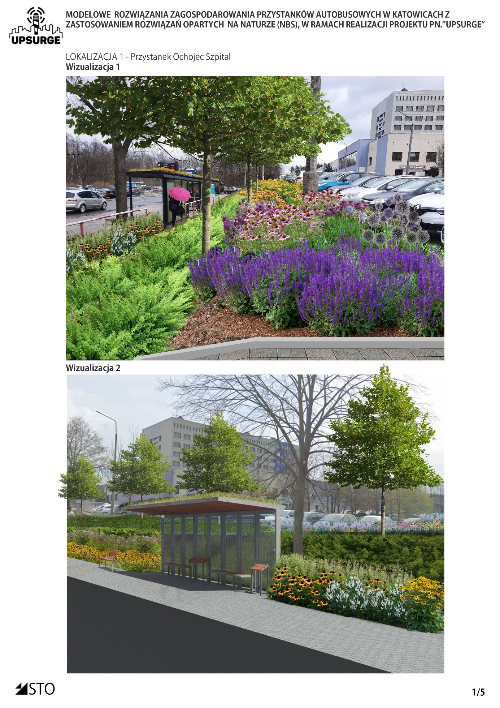

stop / Silesian Parliament Square

Main conceptual assumptions
- Adaptation to the "Concept for the development of Plac Śląski in Katowice" by Meritum Projekt
- Enlargement of the existing rebates and unconcreting the maximum area of pavements, without negatively affecting their functionality
- Unconcreting, if possible, the surface under the candelabra balusters
- Planting attractive bedding plants, resistant to urban conditions, insect-friendly and melliferous
- Tree planting

Expected benefits
- Increasing the areas covered with vegetation will reduce surface runoff of rainwater and increase small retention
- Diversified plantings will increase the biodiversity and visual attractiveness of the site
- Planting a tree over the years will increase the shaded area, which will reduce the heat island effect
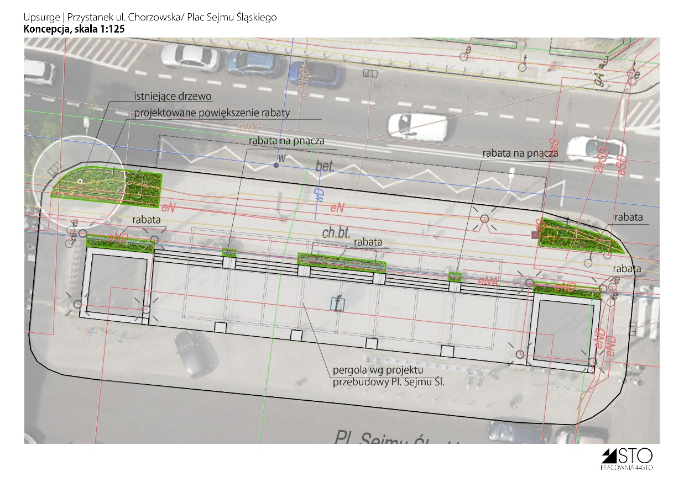
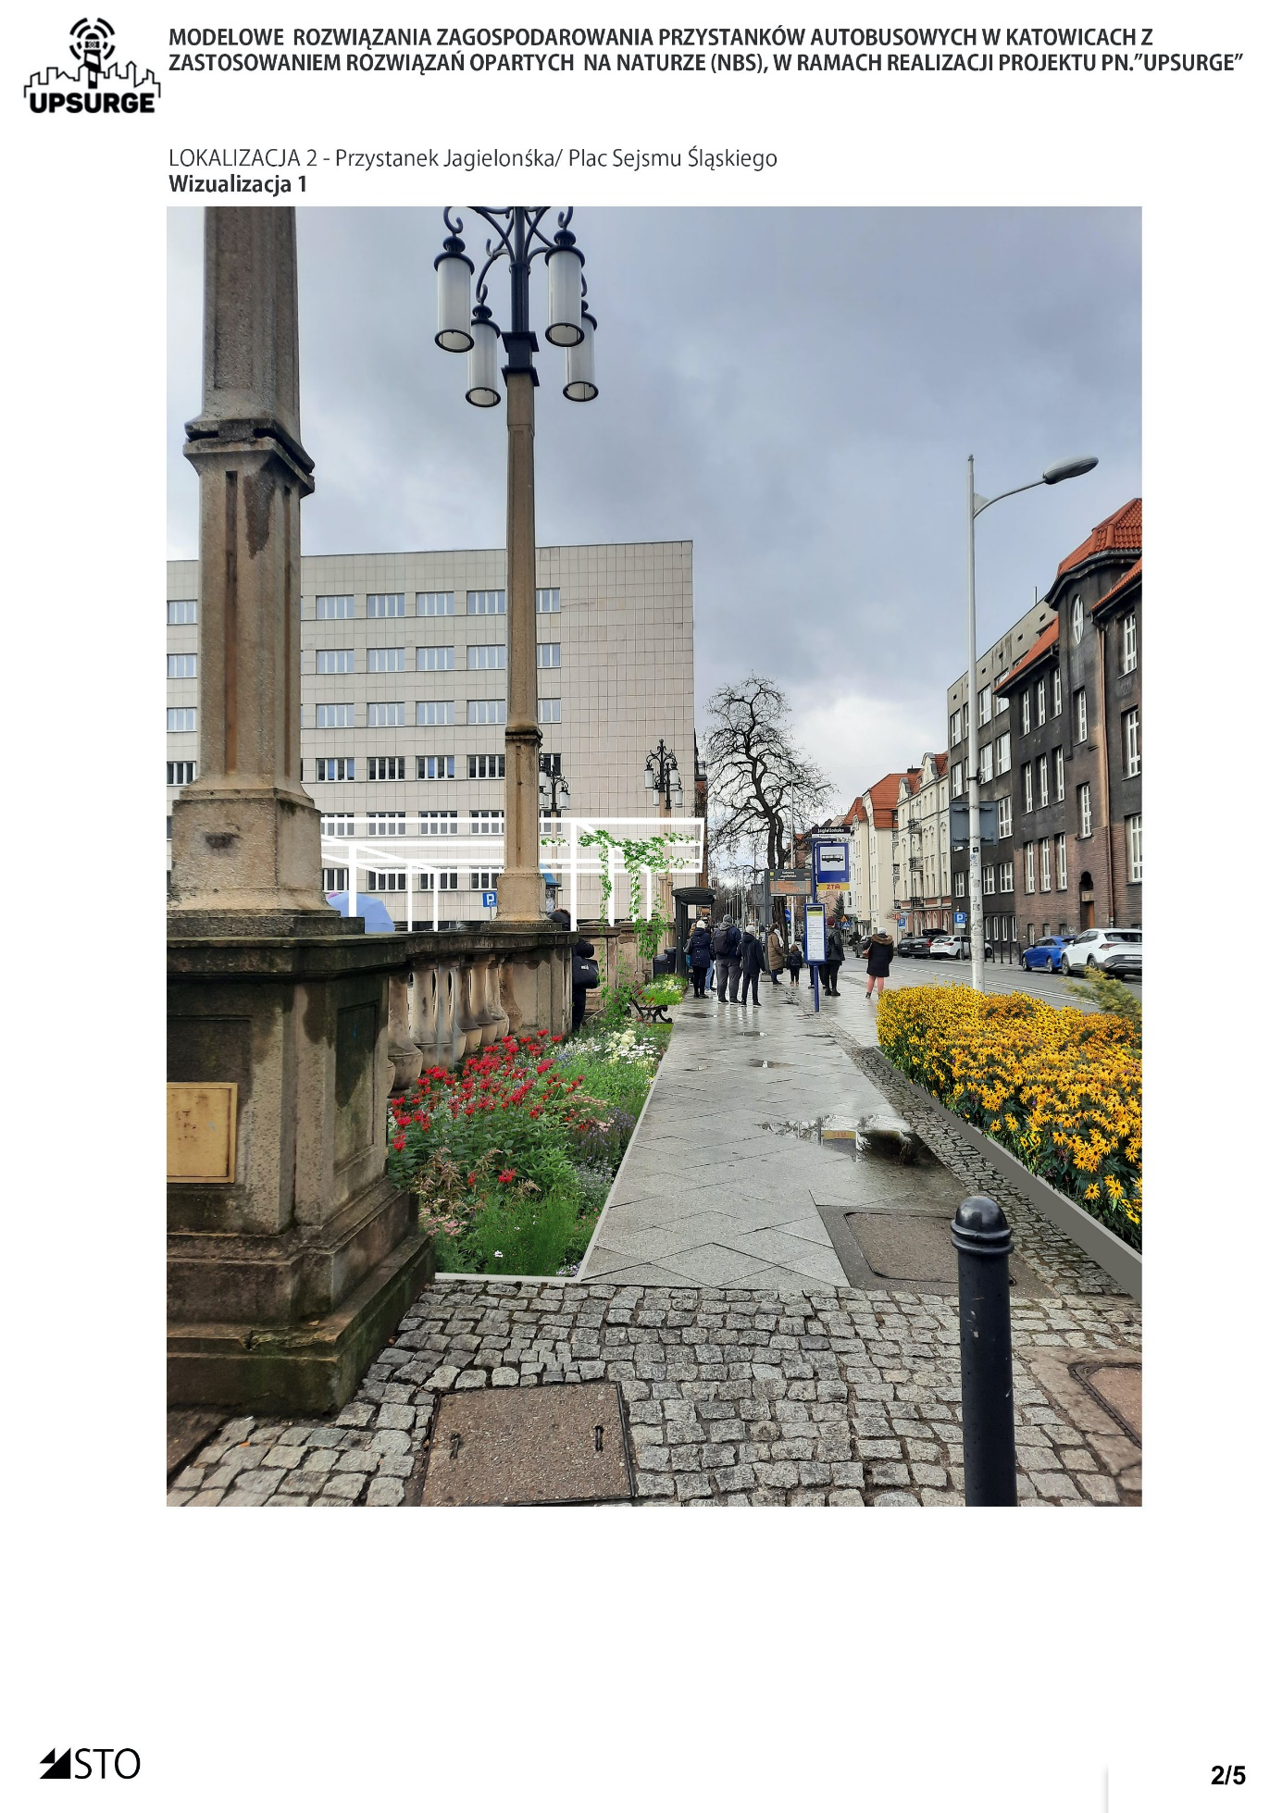

Market Square - ul. Korfanty

Main conceptual assumptions
- Creation of new rebates referring in shape to the existing development of the Market Square in Katowice and inscribing them in the surface drawing
- Maximum unconcreting of the surface, while maintaining its functionality, will reduce surface runoff and increase low retention
- Planting trees to minimize the urban heat island in the future
- Planting resistant grasses, perennials and shrubs will increase the visual value and increase biodiversity

Expected benefits
- Increasing the areas covered with vegetation will reduce surface runoff of rainwater and increase small retention
- Diversified plantings will increase the biodiversity and visual attractiveness of the site
- Planting a tree over the years will increase the shaded area, which will reduce the heat island effect
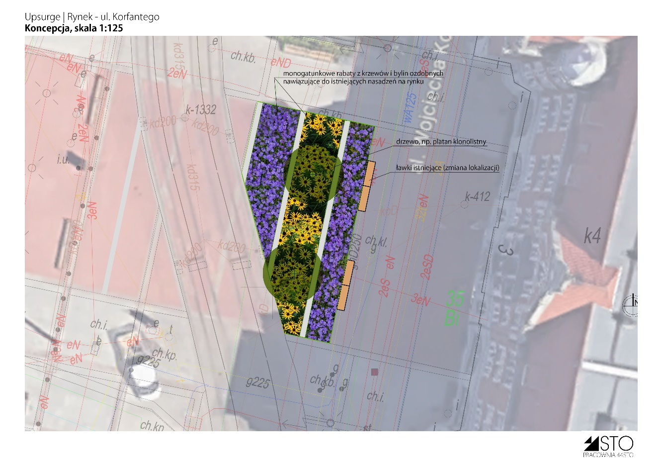
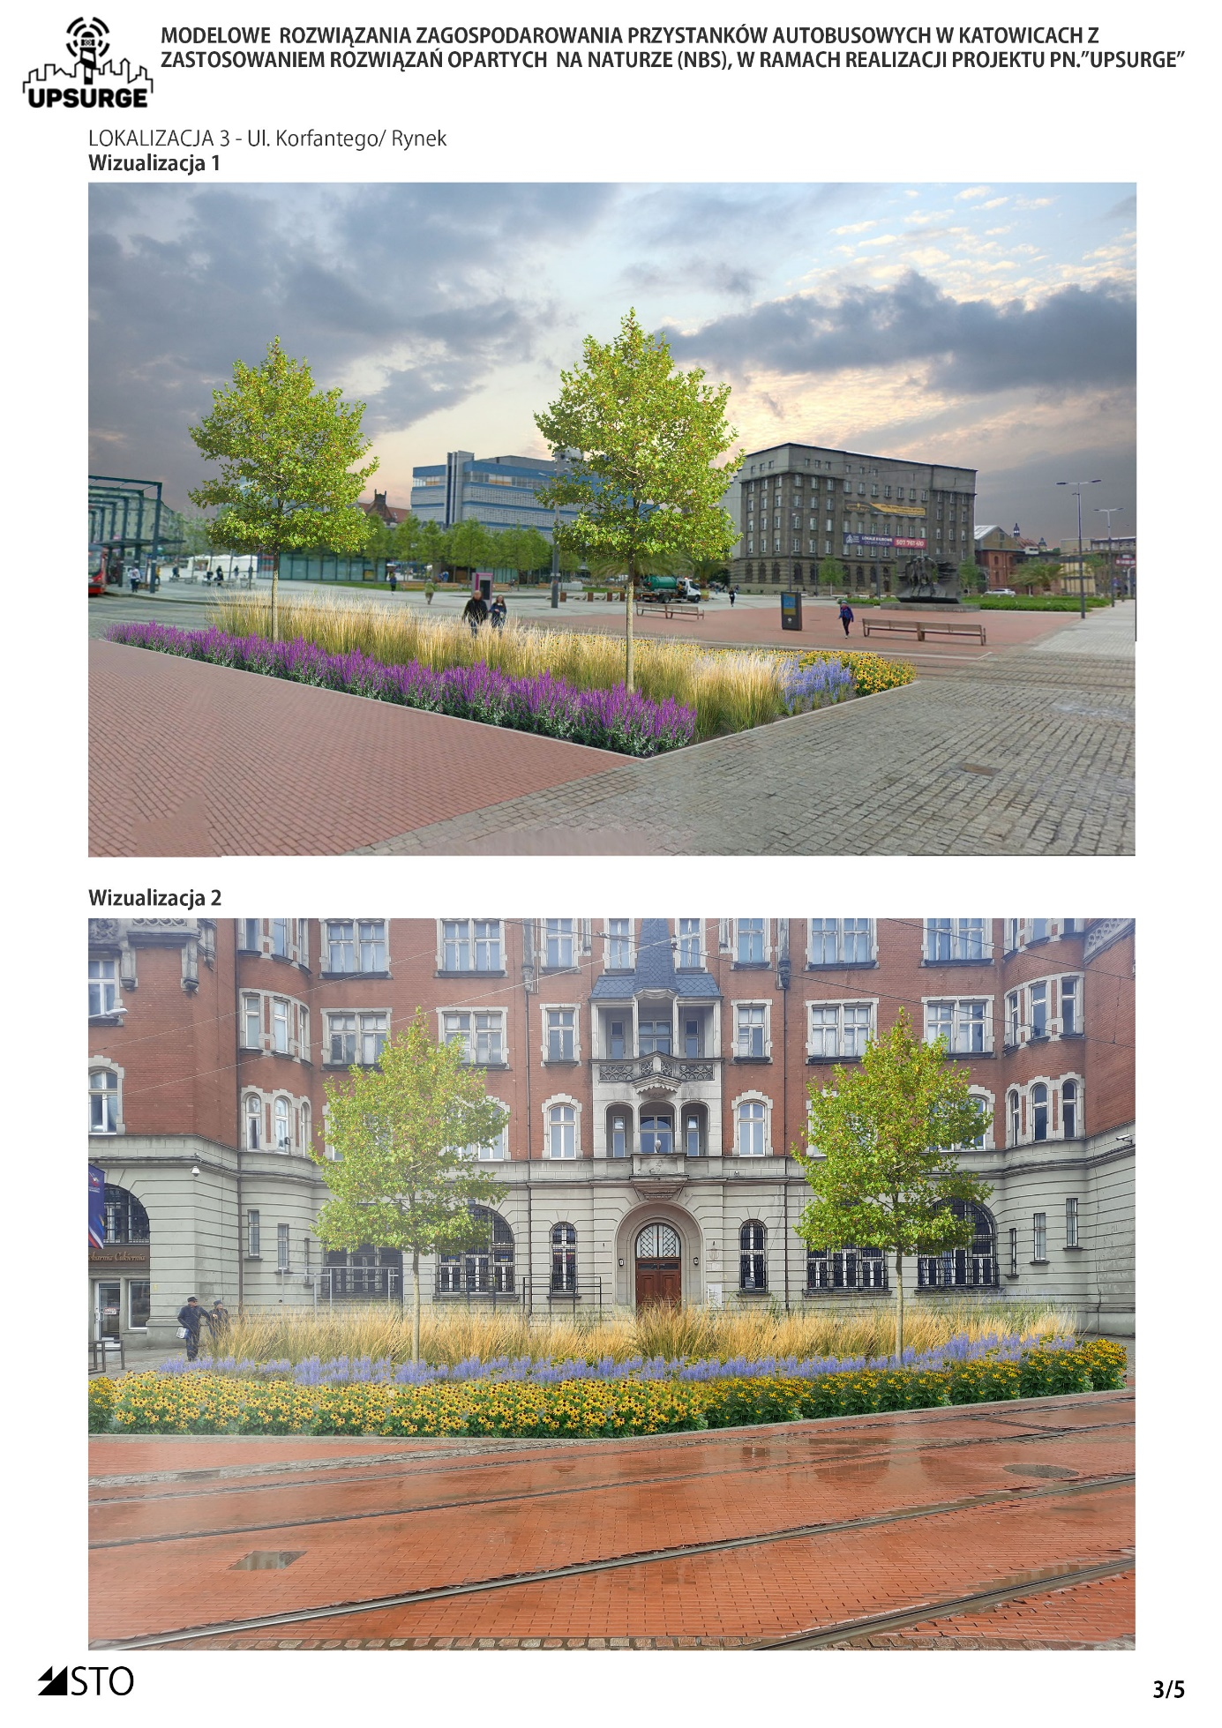

Stop ul. Chorzowska Oak - Church

Main conceptual assumptions
- Designing bus shelters with roofs covered with greenery and two trellises covered with vines
- Planting the rebate at the back and side of the stop with resistant plants
- Planting the area between the bicycle path and the tracks

Expected benefits
- Trellises overgrown with vines will increase shading and thus the comfort of using the space
- Increasing the areas covered with vegetation will reduce surface runoff of rainwater and increase small retention
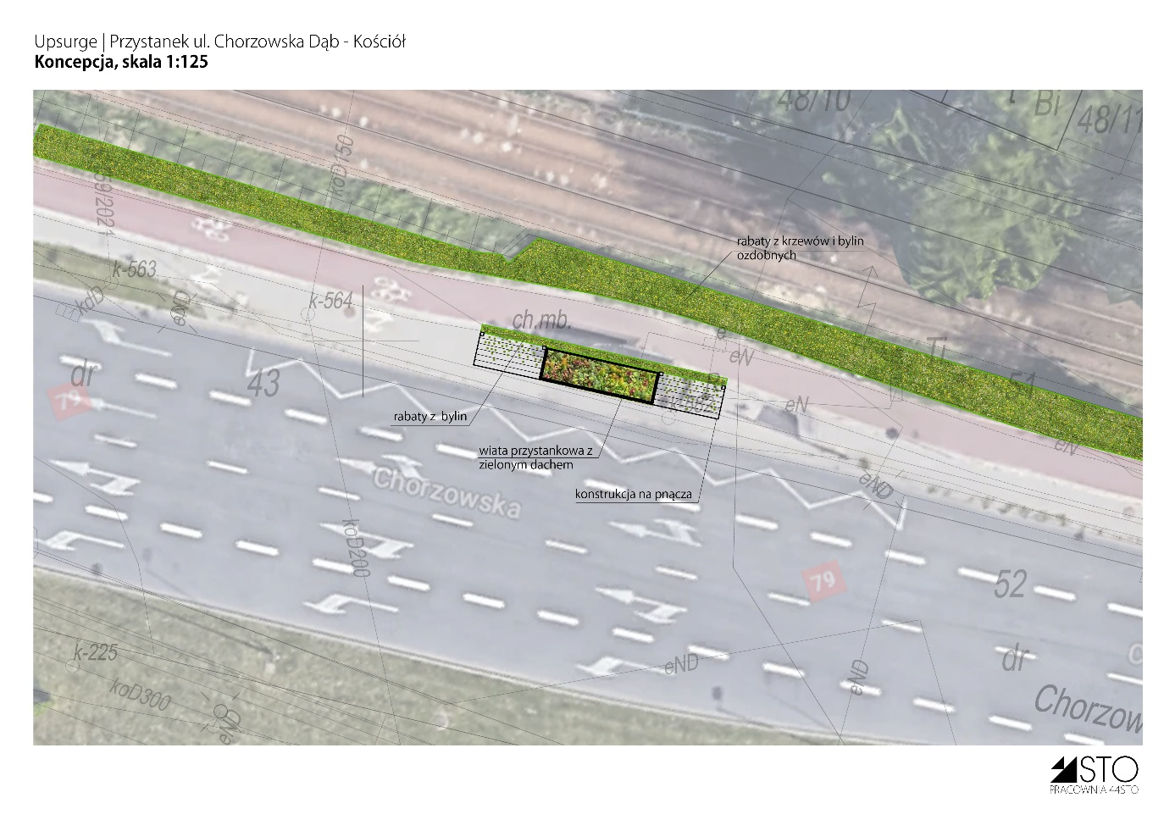
- Diversified plantings will increase the biodiversity and visual attractiveness of the site
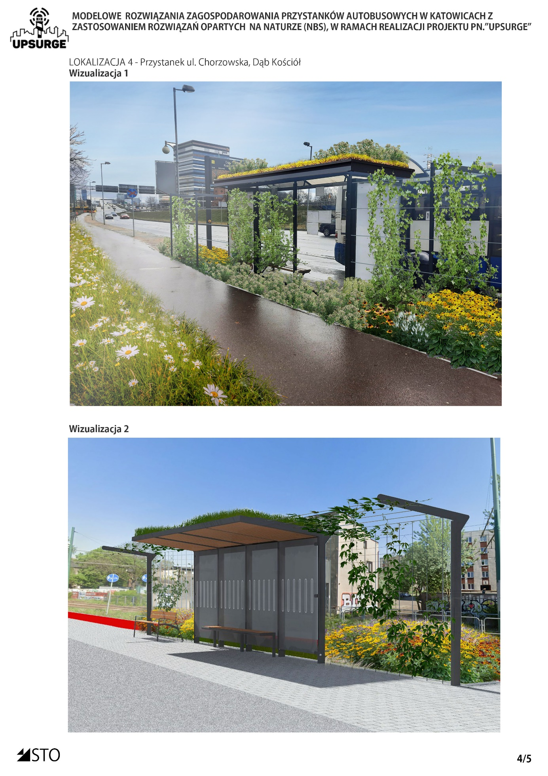

Silesian Park stop

Main conceptual assumptions
- Designing two bus shelters with roofs covered with greenery
- Designing diverse street furniture: benches, squats, litter bins
- Designing a trellis covered with vines
- Maximum unconcreting of the surface, while maintaining its functionality, will reduce surface runoff and increase low retention
- Planting resistant grasses, perennials and shrubs will increase the visual value and increase biodiversity
- Planting a tree

Expected benefits
- The introduction of diverse street furniture and ramps will increase the comfort of users with special needs
- Increasing the areas covered with vegetation will reduce surface runoff of rainwater and increase small retention
- Diversified plantings will increase the biodiversity and visual attractiveness of the site
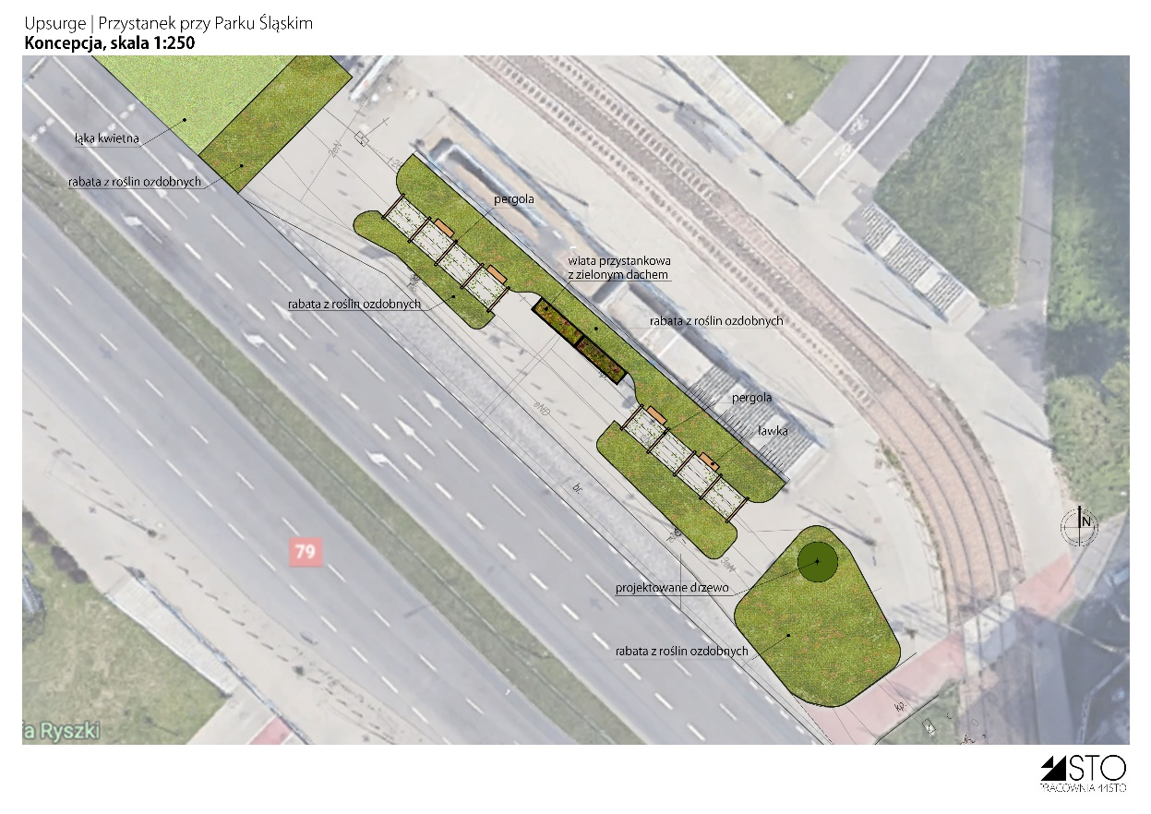
- Planting a tree over the years will increase the shaded area, which will reduce the heat island effect

